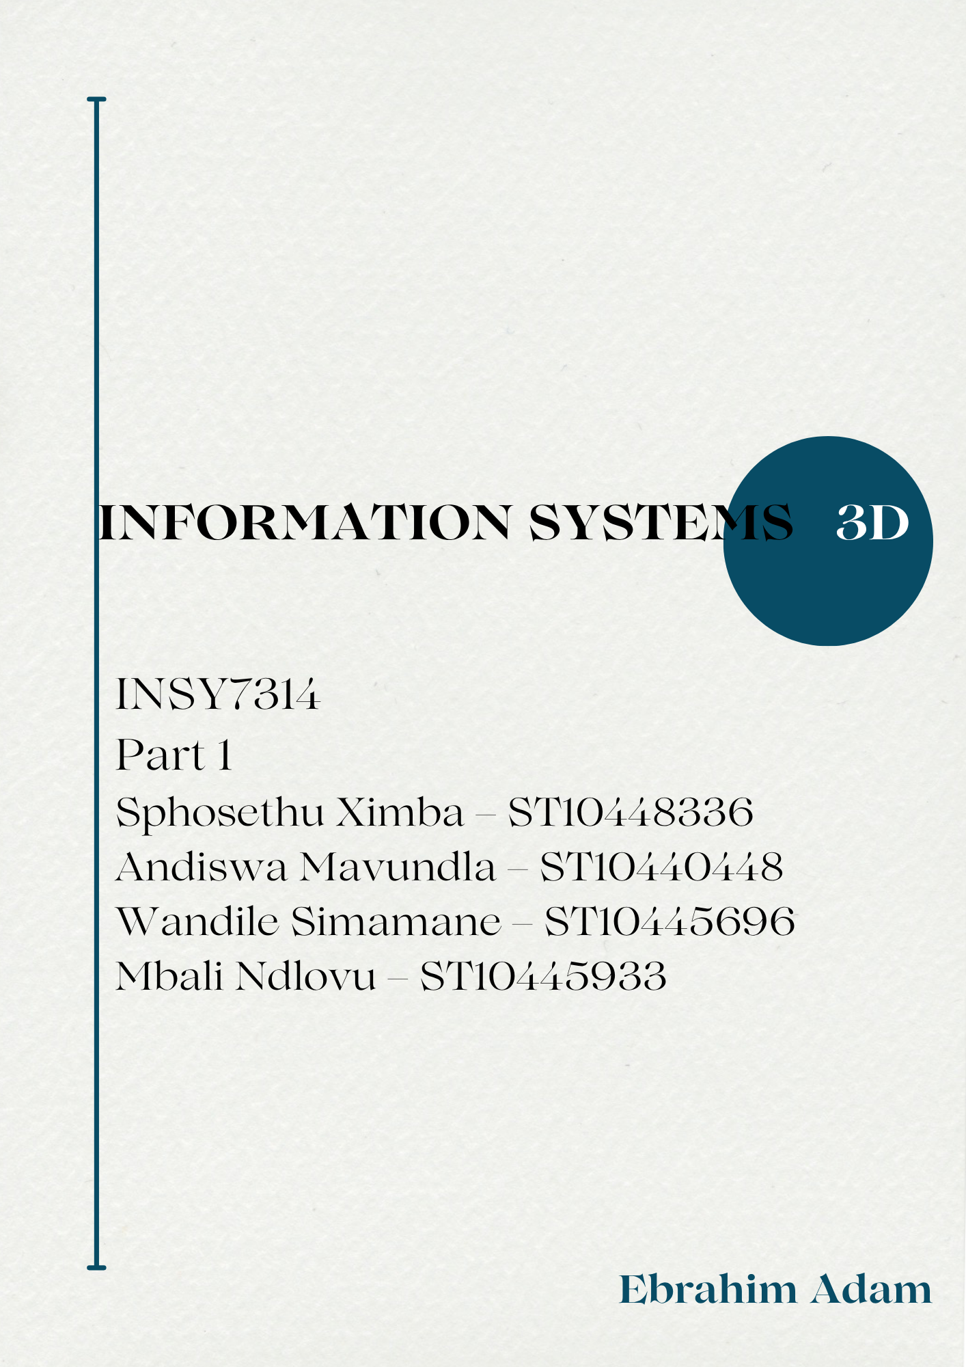
Table of Contents
Screenshots of postman testing 3
Referencing 7

Screenshots of postman testing
Test 1: Successful registration:
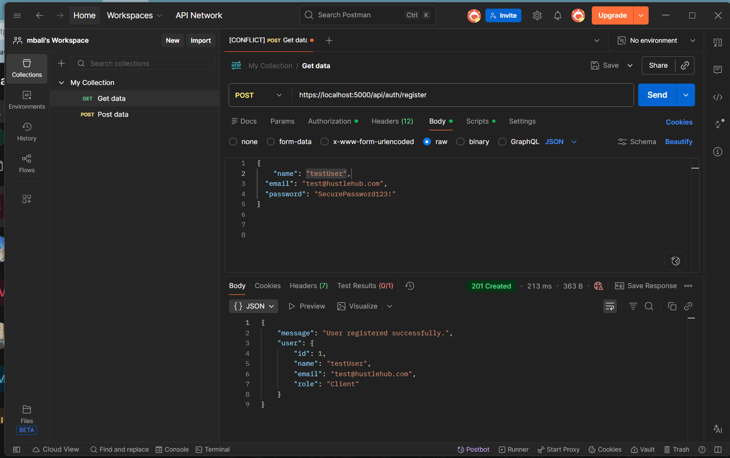

Test 2: Unsuccessful registration (missing name):
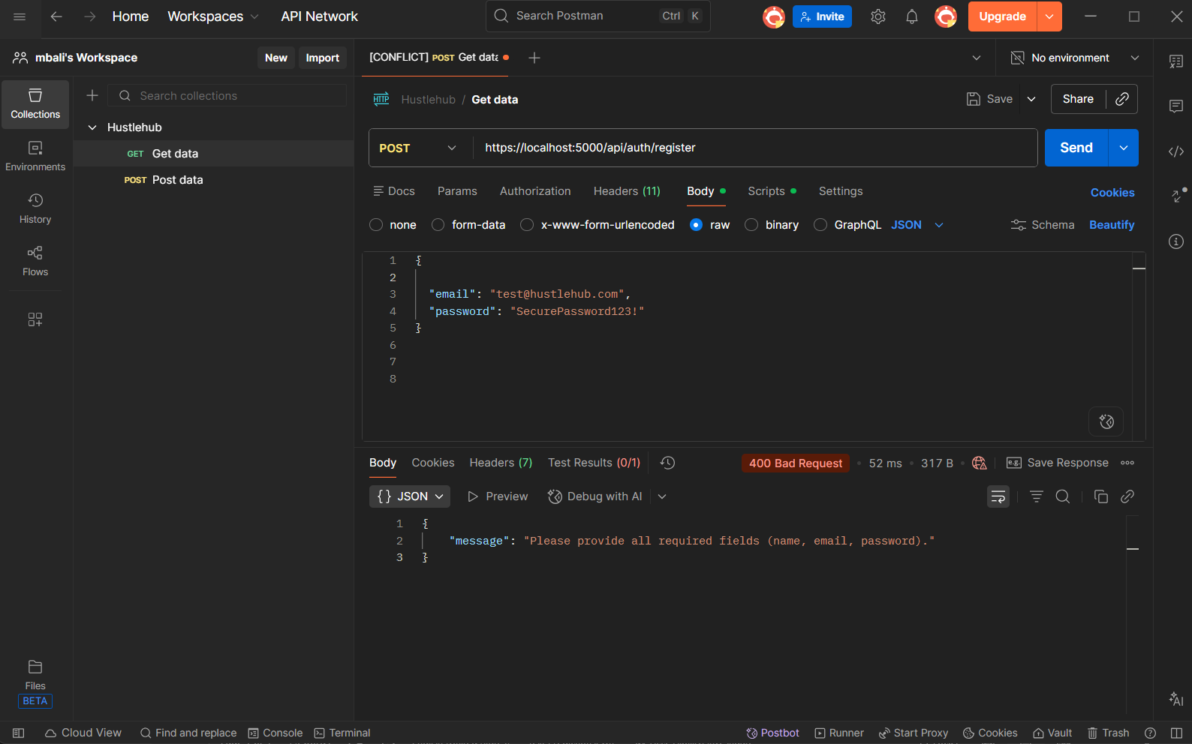

Test 3: Unsuccessful registration (Incorrect password format):
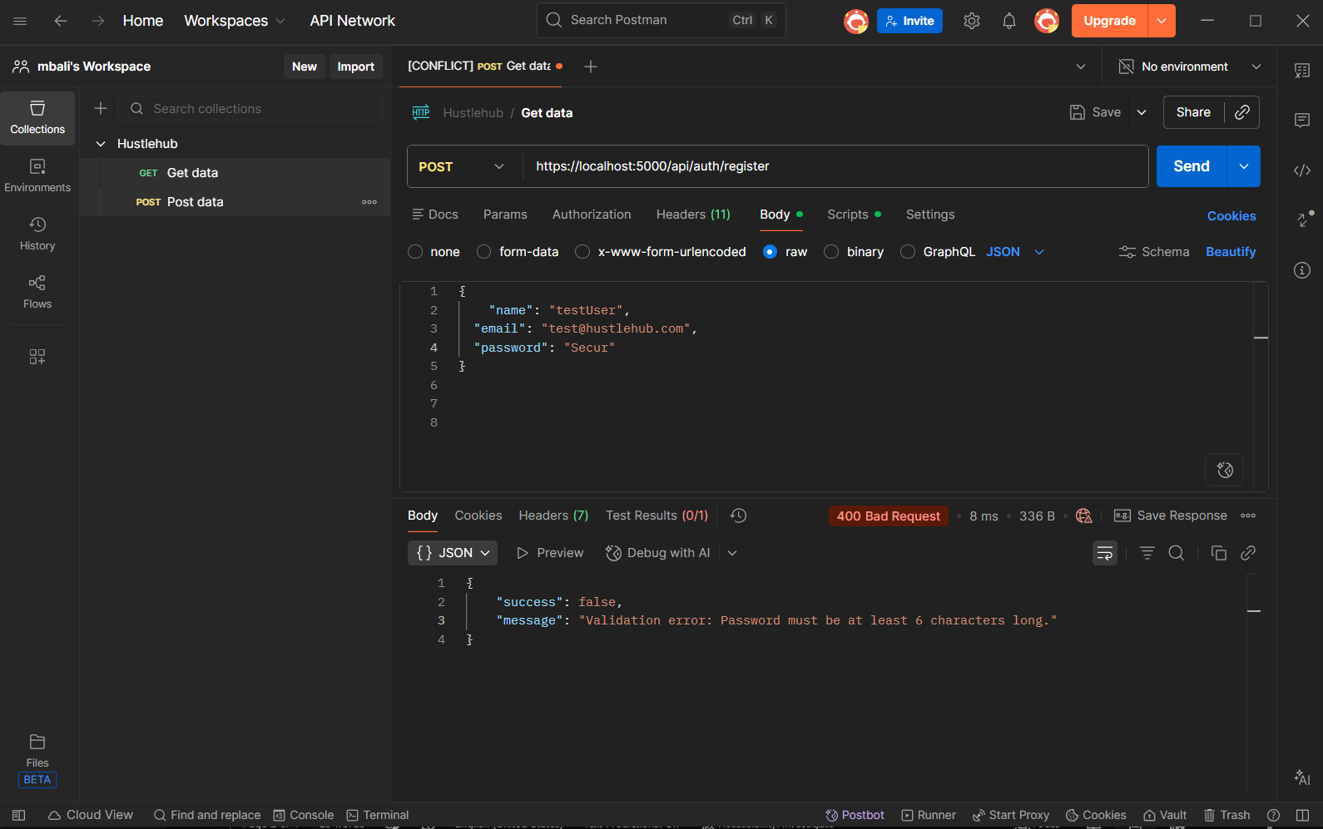

Test 3: Unsuccessful registration (Incorrect email format):
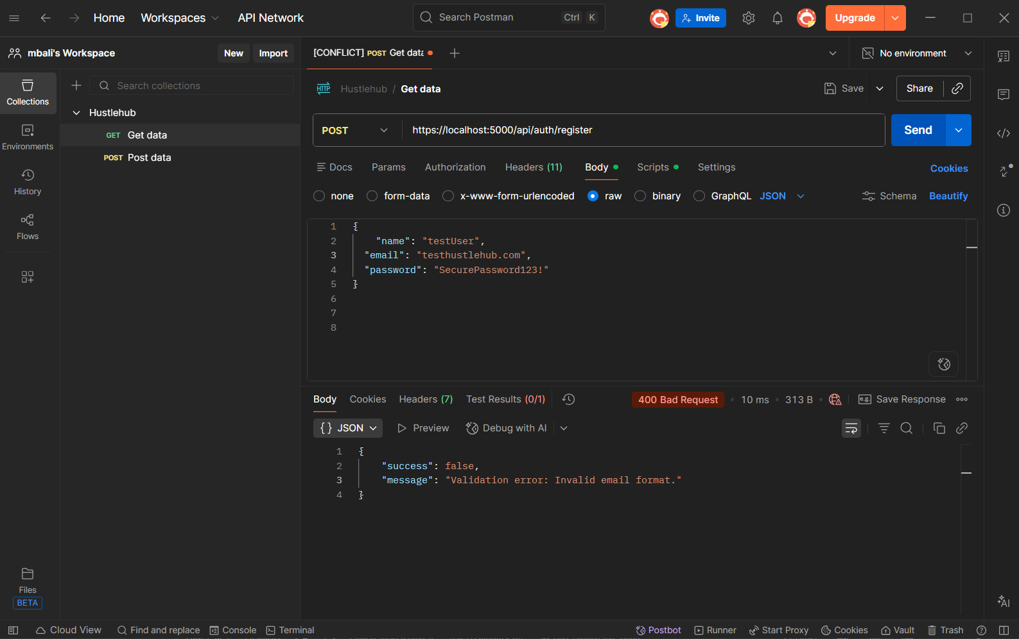

Test 4: Unsuccessful login (Incorrect password):
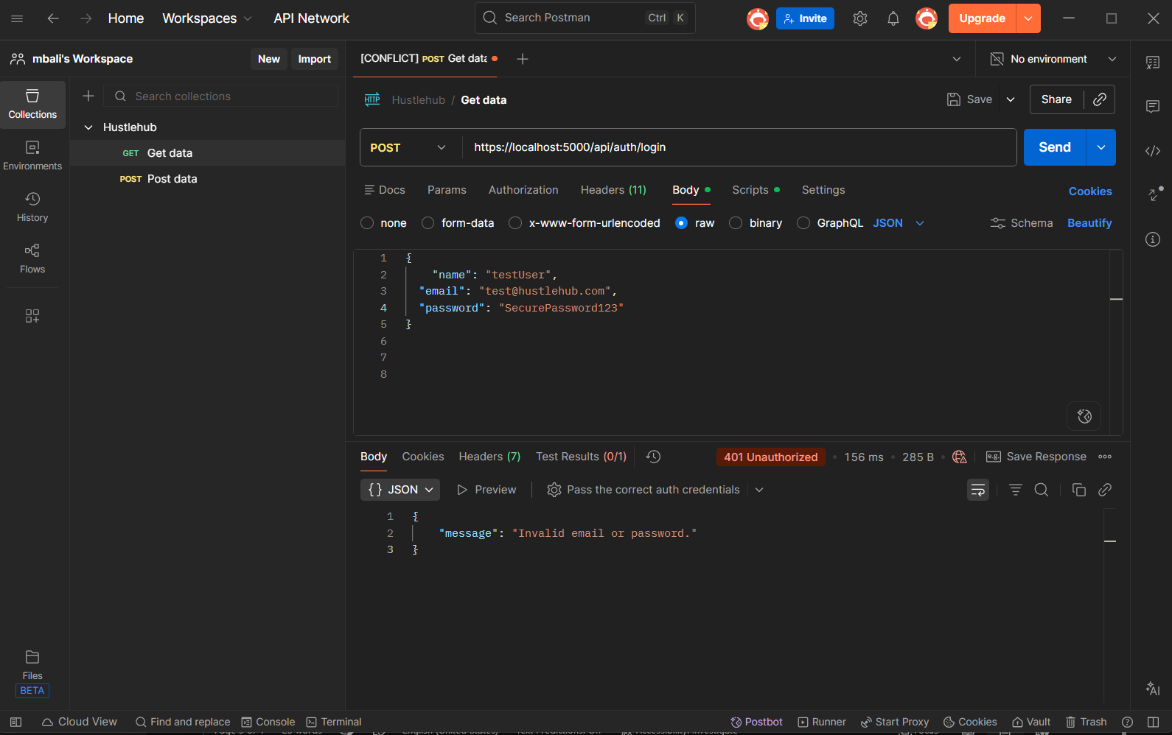
Test 5: Access Protected Route with Token (Success):
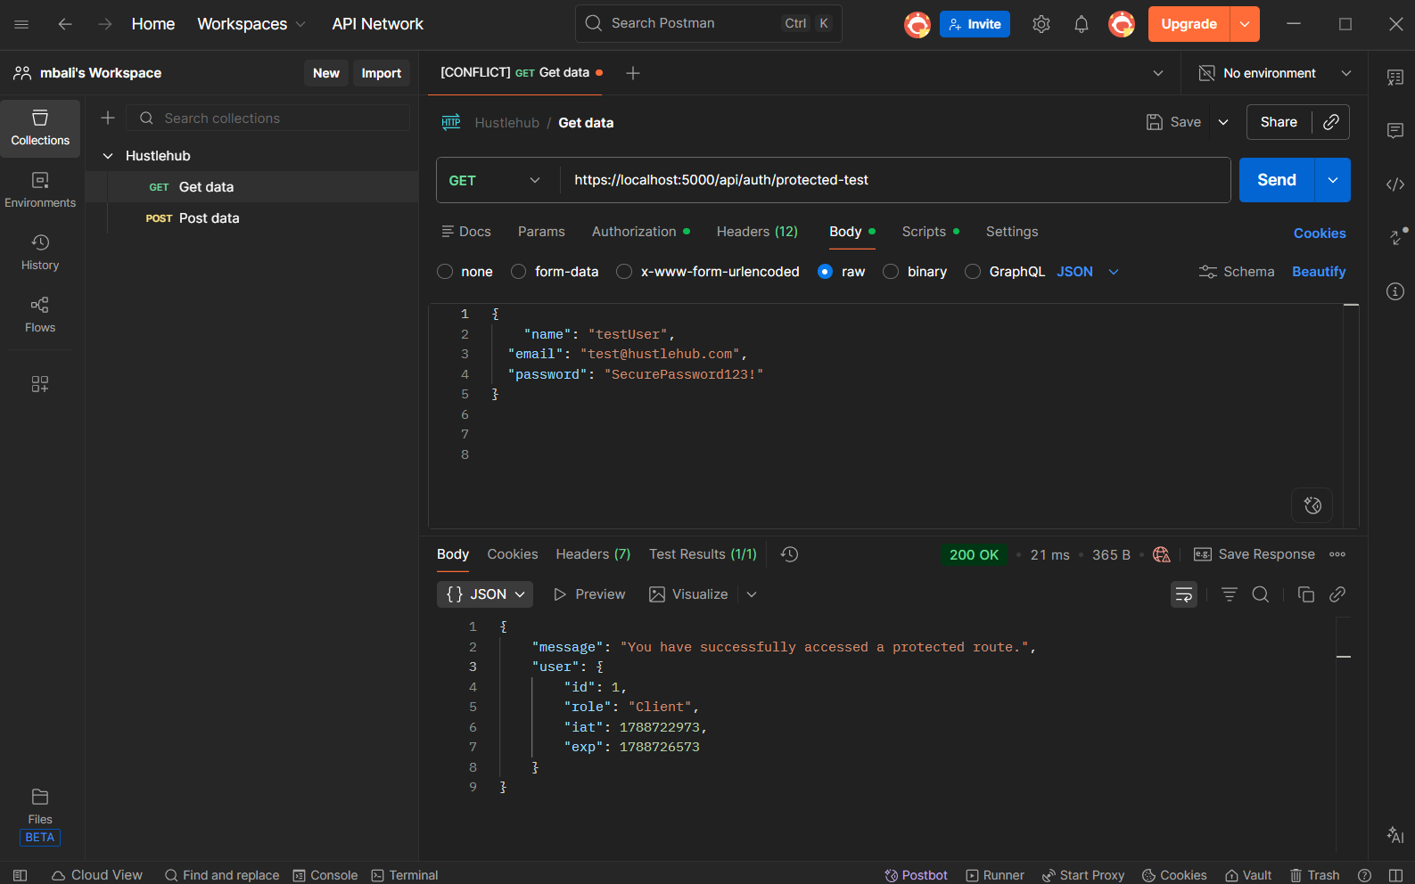

Test 6: Successful login:
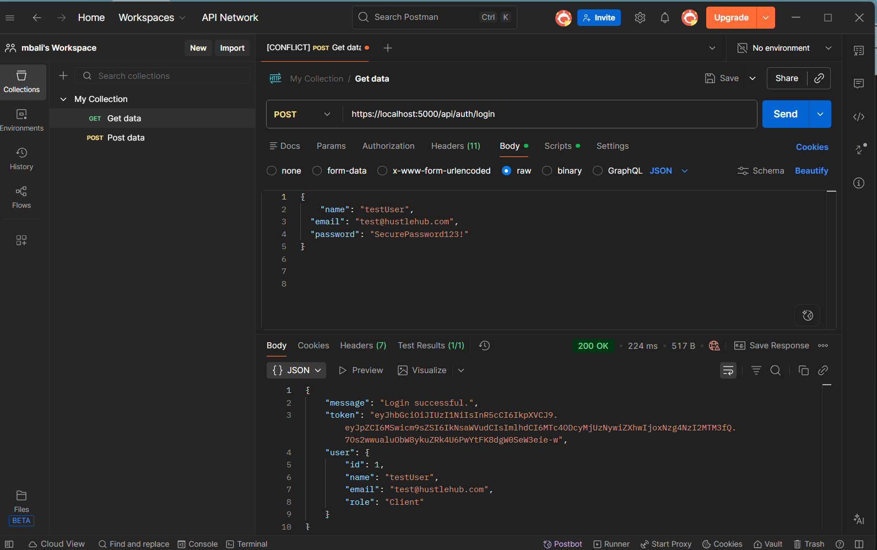

Test 7: Access Protected Route Without Token (Failure):
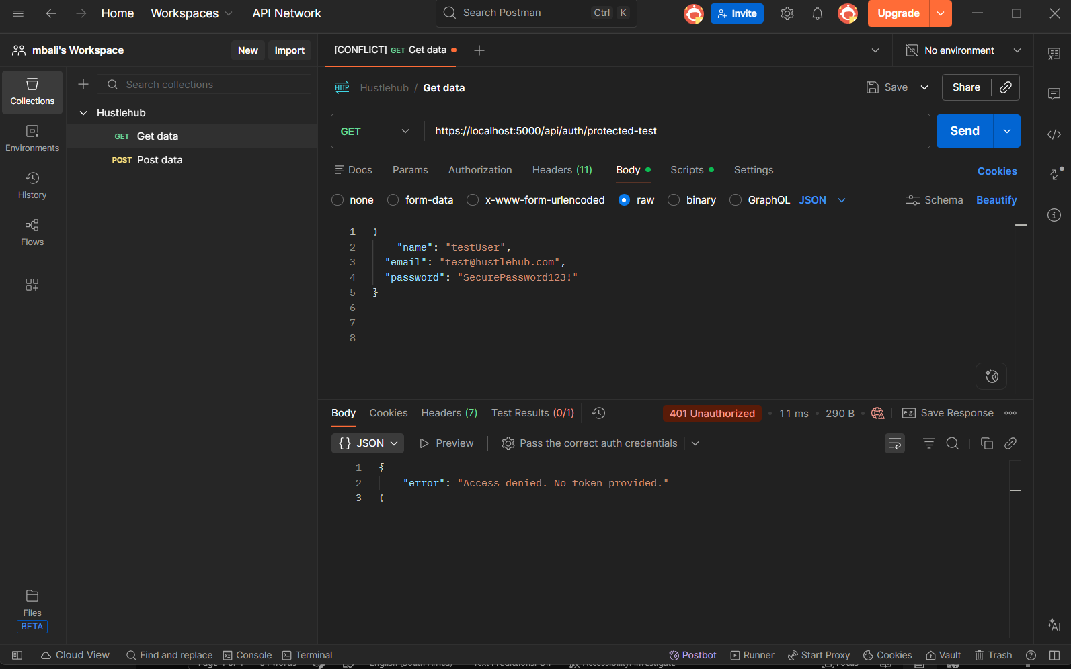

Referencing
Disclosure of AI Usage in the Assessment:
• Section which generative AI was used: POE Part 1
• Name of AI tool used: Gemini AI
• Purpose/Intention behind use: I used Gemini AI as a support tool to help fix coding errors, assist with building the API.
• Date in which generative AI was used: 1 September 2025
• Link to the generative AI: https://gemini.google.com/app/27518195c9725d45

